Tutorial:Team5

# Set up a new role with AWS Lambda-

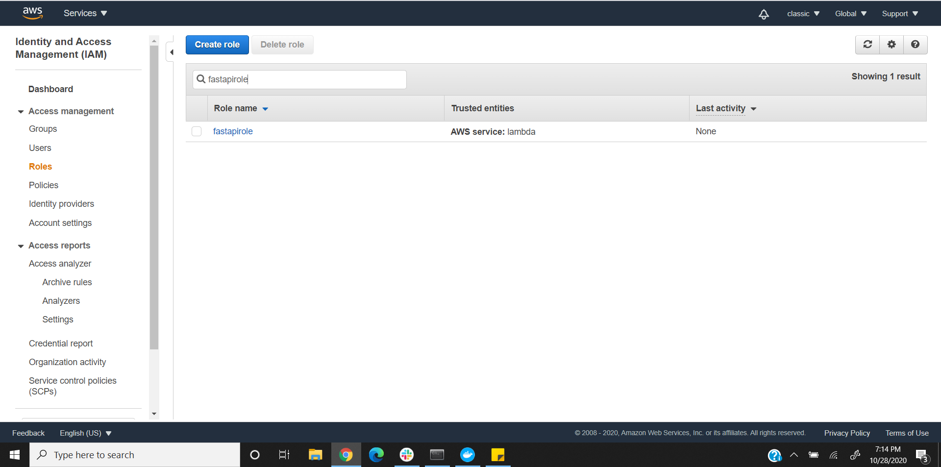

# Set up an AWS S3 bucket:

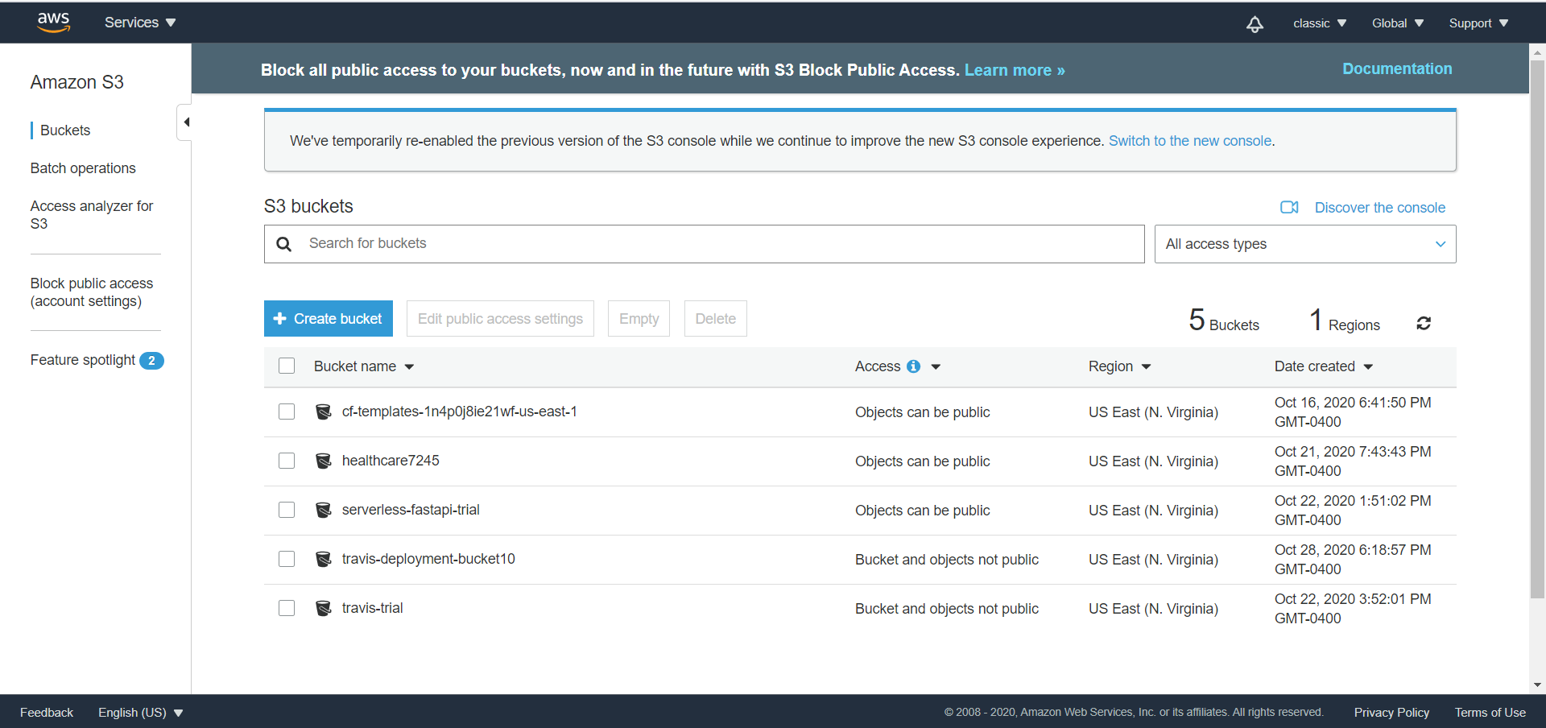

# Set up a Travis user in AWS:

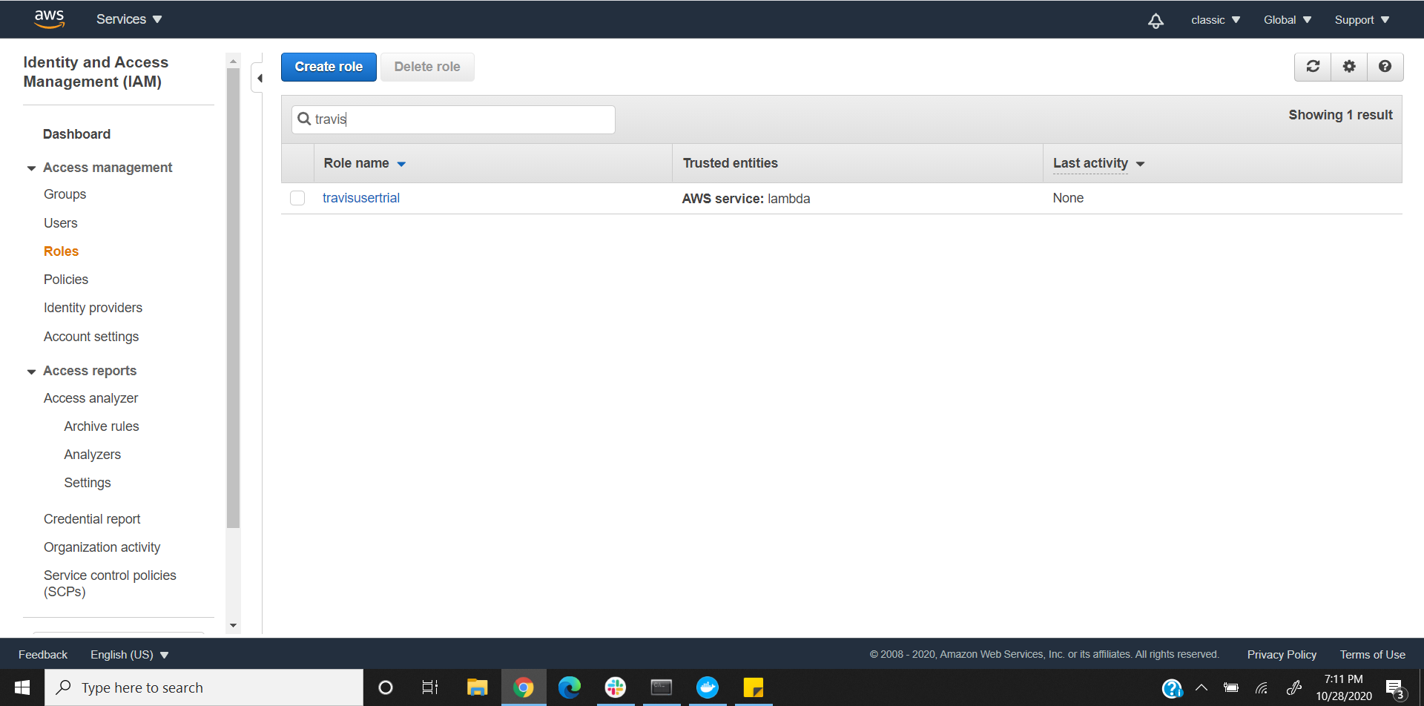

# Test the application Locally and deploy it with AWS SAM:

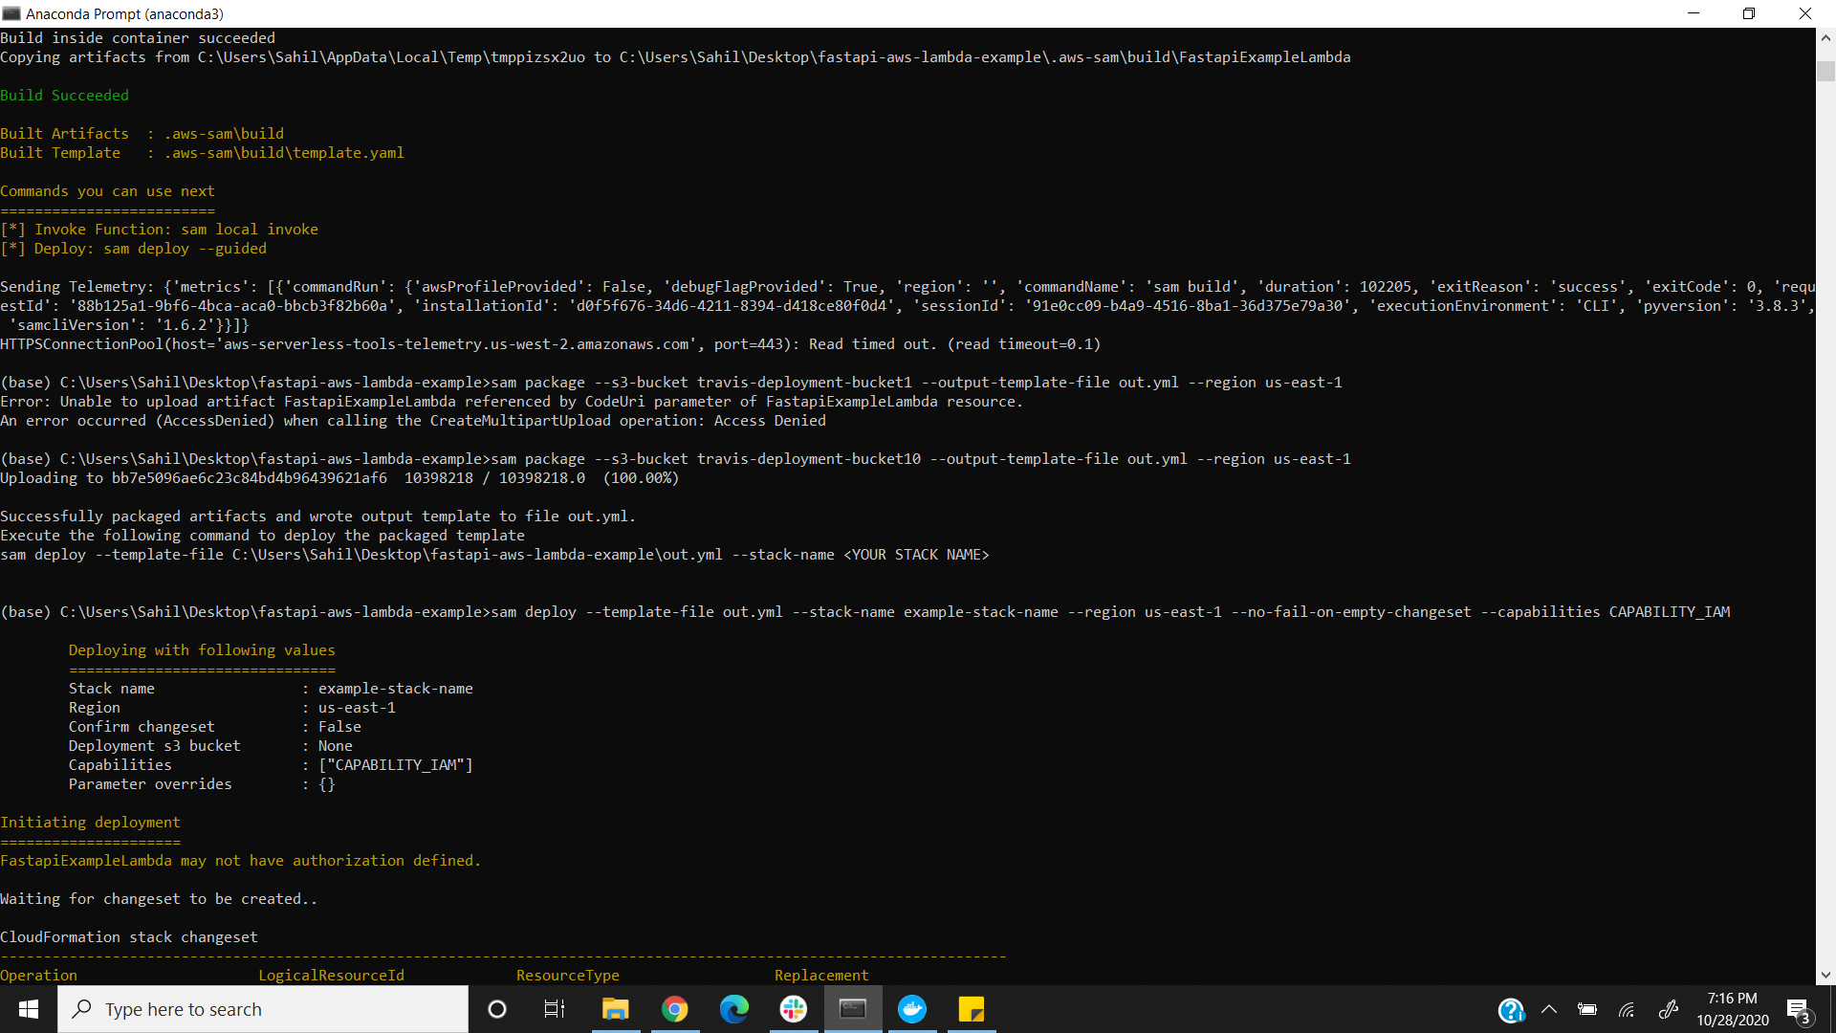

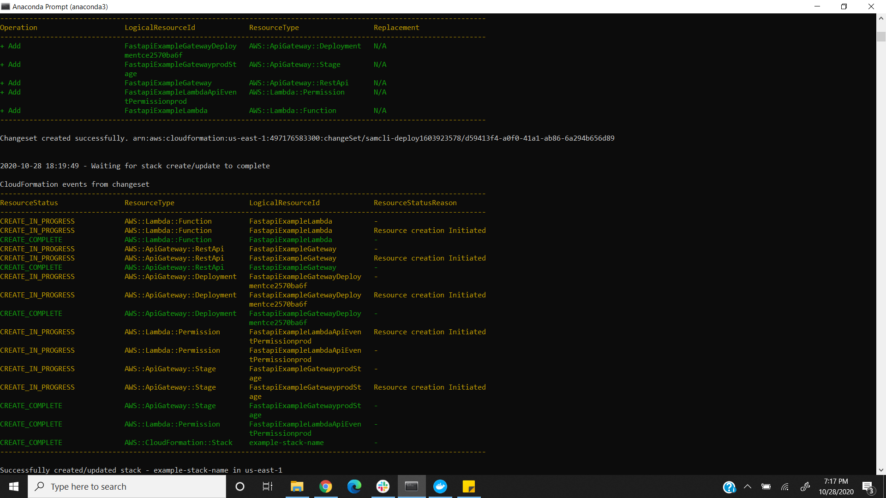

# Token Storing in Dynamodb:

